Name

Mathematics Stage 5 Paths
Algebraic Fractions with Binomial Numerator

Book 1 |  | Version: 261002  Feedback:  https://MrDingMaths.com
Contents
Syllabus Content 2
Learning Intention 3

Syllabus Content
MA5-ALG-P-02 selects and applies appropriate algebraic techniques to operate with algebraic fractions, and expands, factorises and simplifies algebraic expressions
Operate with algebraic fractions involving binomial numerators and numerical denominators
- Add and subtract algebraic fractions with binomial numerators and numerical denominators

Adding Fractions with Binomial Numerators

- Equivalent Fractions with Binomial Numerators
When creating equivalent algebraic fractions:
- Multiply both numerator and denominator by the same factor.
- Remember to multiply each term in the numerator by your factor.
$$=\frac{a+b}{c}×\frac{n}{n}=\frac{n\left(a+b\right)}{cn}$$

- Example Produce equivalent fractions involving binomial numerator
$$\frac{4x+7}{3}=\frac{}{15}$$  $$=\frac{4x+7}{3} \frac{×5}{×5}$$  $$=\frac{5\left(4x+7\right)}{15}$$  $$=\frac{20x+35}{15}$$ | $$\frac{3x+9}{18}=\frac{}{6}$$  $$=\frac{3x+9}{18} \frac{÷3}{÷3}$$  $$=\frac{x+3}{6}$$

- Guided Practice
Determine the equivalent fraction.
- $\frac{2x+1}{3}$ $=$ $\frac{}{12}$  $=$ $\frac{2x+1}{3} \frac{×4}{×4}$  $$\frac{8x+4}{12}$$ | - $\frac{5x-8}{2}$ $=$ $\frac{}{6}$  $$\frac{15x-24}{6}$$ | - $\frac{6x-8}{4} =$ $\frac{}{2}$  $$\frac{3x-4}{2}$$
- $\frac{12x+14}{6}$ $=$ $\frac{}{3}$  $$\frac{6x+7}{3}$$ | - $\frac{11x+2}{4} =$ $\frac{}{-12}$  $$\frac{-33x-6}{-12}$$ | - $\frac{3x-20}{6}$ $=$ $\frac{}{30}$  $$\frac{15x-100}{30}$$

- Key Ideas
- When making equivalent fractions, if there is more than one term in the numerator, we need to multiply …………… term.
- Adding Fractions with Binomial Numerators
- Rewrite the fractions with the lowest common multiple of the denominators.
- Add the numerators.
- Expand and simplify.

- Example Produce equivalent fractions involving binomial numerator
$$\frac{y+1}{5} + \frac{2y}{3}$$  1. same denominators $\frac{3(y+1)}{15}$ $+$ $\frac{5(2y)}{15}$  2. add numerators $\frac{3\left(y+1\right)+5(2y)}{15}$  3. simplify $\frac{3y+3+10y}{15}$  $=$ $\frac{13y+3}{15}$ | $$\frac{x+3}{2}+\frac{x-2}{5}$$  1. same denominators $\frac{5(x+3)}{10}$ $+$ $\frac{2(x-2)}{10}$  2. add numerators $\frac{5\left(x+3\right)+2(x-2)}{10}$  3. simplify $\frac{5x+15+2x-4}{10}$  $=$ $\frac{7x+11}{10}$

- Guided Practice
Simplify these expressions.
- $\frac{x+6}{2}+\frac{x}{5}$  $$=\frac{( )}{10}+\frac{}{10}$$  $$\frac{7x+30}{10}$$ | - $\frac{x+3}{3}+\frac{x}{4}$  $$=\frac{( )}{12}+\frac{}{12}$$  $$\frac{7x+12}{12}$$ | - $\frac{2x+5}{5}+\frac{x}{10}$  $$\frac{x+2}{2}$$
- $\frac{x+1}{2}+\frac{x+3}{5}$  $$\frac{7x+11}{10}$$ | - $\frac{y+4}{5}+\frac{y-3}{6}$  $$\frac{11y+9}{30}$$ | - $\frac{2x-3}{6}+\frac{x+2}{8}$  $$\frac{11x-6}{24}$$

Foundation
- Complete these simplifications.
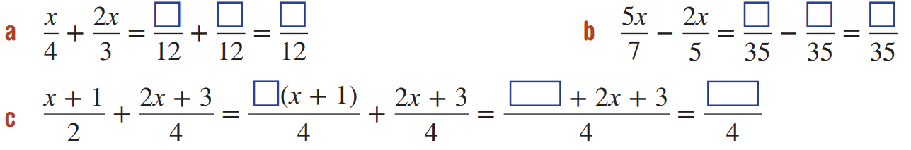  $$\frac{11x}{12}$$ | $$\frac{11x}{35}$$ | $$\frac{4x+5}{4}$$

- Simplify these algebraic fractions.
- $\frac{m}{3}+\frac{m+5}{4}$  $$\frac{7m+15}{12}$$ | - $\frac{4p-3}{5}-\frac{2p}{7}$  $$\frac{18p-21}{35}$$ | - $\frac{p}{3}+\frac{p+2}{4}$  $$\frac{7p+6}{12}$$
- $\frac{x}{2}+\frac{3x}{4}$  $$\frac{5x}{4}$$ | - $\frac{y+1}{5}+\frac{2y}{3}$  $$\frac{13y+3}{15}$$ | - $\frac{a+2}{3}-\frac{a}{4}$  $$\frac{a+8}{12}$$
- $\frac{k+4}{3}+\frac{k-2}{5}$  $$\frac{8k+14}{15}$$ | - $\frac{x+2}{3}+\frac{x+1}{4}$  $$\frac{7x+11}{12}$$ | - $\frac{x-3}{4}+\frac{x+2}{2}$  $$\frac{3x+1}{4}$$
- $\frac{2x+1}{2}+\frac{x-2}{3}$  $$\frac{8x-1}{6}$$ | - $\frac{3y-5}{4}+\frac{2y-7}{10}$  $$\frac{19y-39}{20}$$ | - $\frac{2x+3y}{6}+\frac{5x-2y}{12}$  $$\frac{9x+4y}{12}$$
- $\frac{5x+3}{14}+\frac{2x-2}{3}$  $$\frac{43x-19}{42}$$ | - $\frac{3-x}{14}+\frac{x-1}{7}$  $$\frac{x+1}{14}$$ | - $\frac{2x-3y}{8}+\frac{2y+x}{7}$  $$\frac{22x-5y}{56}$$

Development
- Describe the mistake and provide the correct solution.
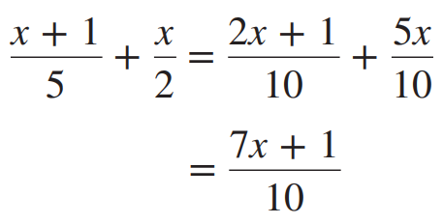  Mistake:  Correct solution:  $$\frac{7x+2}{10}$$ | 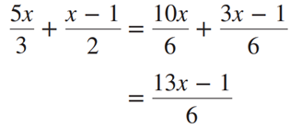  Mistake:  Correct solution:  $$\frac{13x-3}{6}$$

- A student thinks that the common denominator to use when simplifying $\frac{x+1}{2}+\frac{2x-1}{4}$ is 8.
- Complete the addition by making both denominators 8. | - Complete the simplification using the actual LCD of 4.
  - You should have the same answer for both methods. Which do you prefer and why?
…………………………………………………………………………………………………………

- Simplify these algebraic fractions.
- $\frac{2x}{5}-\frac{3x}{2}-\frac{x}{3}$  $$\frac{-43x}{30}$$ | - $\frac{x}{4}-\frac{2x}{3}+\frac{5x}{6}$  $$\frac{5x}{12}$$ | - $\frac{5x}{8}-\frac{5x}{6}+\frac{3x}{4}$  $$\frac{13x}{24}$$
- $\frac{x+1}{4}+\frac{2x-1}{3}-\frac{x}{5}$  $$\frac{43x-5}{60}$$ | - $\frac{2x-1}{3}-\frac{2x}{7}+\frac{x-3}{6}$  $$\frac{23x-35}{42}$$ | - $\frac{1-2x}{5}-\frac{3x}{8}+\frac{3x+1}{2}$  $$\frac{28+29x}{40}$$

Subtracting Fractions with Binomial Numerators

- Negative Fractions
A negative symbol in line with the fraction bar has several possible interpretations;
you can expand the negative into either the numerator or denominator, but not both.
$$-\frac{a}{b}=\frac{-a}{b}=\frac{a}{-b}$$
$$-\frac{a+b}{c}=\frac{-a-b}{c}=\frac{a+b}{-c}$$

- Working with Negative Fractions
Write as many equivalent fractions as possible.
- $-\frac{3}{5}=$
- $-\frac{x+y}{3}=$
- $-\frac{x-y}{3}=$
- $\frac{x-y}{3}=$
- $-\frac{x+y}{a+b}=$
- $-\frac{x-y}{a+b}=$
- $-\frac{x+y}{a-b}=$
- $-\frac{x-y}{a-b}=$
True or false?
- $\frac{a+b}{c}=\frac{-a-b}{-c}$ | - $\frac{a+b}{-c}=\frac{-a+b}{c}$ | - $-\frac{a+b}{c}=\frac{-(a+b)}{c}$
- $-\frac{a-b}{c}=\frac{b-a}{c}$ | - $-\frac{a+b}{c}=\frac{-a-b}{-c}$ | - $\frac{a-b}{c-d}=\frac{b-a}{d-c}$

- Subtracting Fractions with Binomial Numerators
- Rewrite the fractions with the lowest common multiple of the denominators.
- Subtract the numerator.
- Expand and simplify.

- Example Subtract algebraic fractions with binomial numerators
$$\frac{x-1}{3}-\frac{x+4}{5}$$  1. same denominators $\frac{5(x-1)}{15}$ $-$ $\frac{3(x+4)}{15}$  2. subtract $\frac{5\left(x-1\right)-3\left(x+4\right)}{15}$  3. simplify $\frac{5x-5-3x-12}{15}$  $=$ $\frac{2x-17}{15}$ | $$\frac{2x-3}{6}-\frac{3-x}{5}$$  1. same denominators $\frac{5(2x-3)}{30}$ $-$ $\frac{6(3-x)}{30}$  2. subtract $\frac{5\left(2x-3\right)-6(3-x)}{30}$  3. simplify $\frac{10x-15-18+6x}{30}$  $=$ $\frac{16x-33}{30}$

- Guided Practice
Simplify these expressions.
- $\frac{x-4}{2}-\frac{x+2}{3}$  $$=\frac{3( )}{6}-\frac{2( )}{6}$$  $$=\frac{3\left( \right)-2( )}{6}$$  $$\frac{x-16}{6}$$ | - $\frac{x+1}{2}-\frac{2x+3}{5}$  $$\frac{x-1}{10}$$ | - $\frac{2x+1}{4}-\frac{2-x}{3}$  $$\frac{10x-5}{12}$$

- Key Ideas
- When subtracting fractions, remember to take the ………………… of each term in the numerator.

Foundation
- Simplify these algebraic fractions.
- $\frac{9w}{10}-\frac{w+5}{3}$  $$\frac{17w-50}{30}$$ | - $\frac{5a}{9}-\frac{2a+5}{6}$  $$\frac{4a-15}{18}$$ | - $\frac{2a}{6}-\frac{a-5}{8}$  $$\frac{5a+15}{24}$$
- $\frac{x+3}{4}-\frac{x+2}{3}$  $$\frac{-x+1}{12}$$ | - $\frac{3-x}{5}-\frac{x+4}{2}$  $$\frac{-7x-14}{10}$$ | - $\frac{5x-1}{4}-\frac{2+x}{8}$  $$\frac{9x-4}{8}$$
- $\frac{1+3x}{4}-\frac{2x+3}{6}$  $$\frac{5x-3}{12}$$ | - $\frac{x+5}{5}-\frac{x-1}{2}$  $$\frac{-3x+15}{10}$$ | - $\frac{5x-9}{7}-\frac{2-x}{3}$  $$\frac{22x-41}{21}$$
- $\frac{4x+3}{3}-\frac{5-2x}{9}$  $$\frac{14x+4}{9}$$ | - $\frac{2x-1}{4}-\frac{1-3x}{14}$  $$\frac{20x-9}{28}$$ | - $\frac{3x-2}{8}-\frac{4x-3}{7}$  $$\frac{-11x+10}{56}$$

- Read the example carefully and answer the questions.
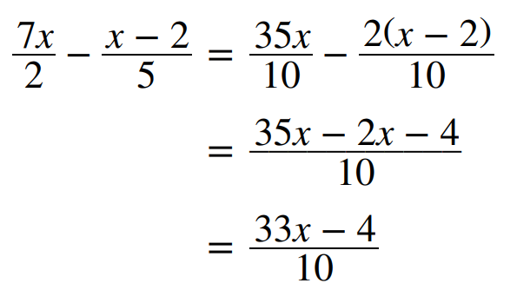 | Explain why $-2x-4$ is incorrect.  $$-2\left(x-2\right)=-2x+4$$  Hence simplify the fractions correctly.  $$\frac{33x+4}{10}$$

Development
- Simplify these algebraic fractions.
- $\frac{x+1}{2}+\frac{x+3}{5}$  $$\frac{7x+11}{10}$$ | - $\frac{x+3}{3}+\frac{x-4}{4}$  $$\frac{7x}{12}$$ | - $\frac{a-2}{7}+\frac{a-5}{8}$  $$\frac{15a-51}{56}$$
- $\frac{y+4}{5}+\frac{y-3}{6}$  $$\frac{11y+9}{30}$$ | - $\frac{m-4}{8}+\frac{m+6}{5}$  $$\frac{13m+28}{40}$$ | - $\frac{x-2}{12}+\frac{x-3}{8}$  $$\frac{5x-13}{24}$$
- $\frac{y+4}{5}-\frac{y-3}{6}$  $$\frac{y+41}{30}$$ | - $\frac{m-4}{8}-\frac{m+6}{5}$  $$\frac{-3m-68}{40}$$ | - $\frac{x-2}{12}-\frac{x-3}{8}$  $$\frac{-x+5}{24}$$
- $\frac{2b-3}{6}+\frac{b+2}{8}$  $$\frac{11b-6}{24}$$ | - $\frac{3x+8}{6}+\frac{2x-4}{3}$  $$\frac{7x}{6}$$ | - $\frac{2y-5}{7}+\frac{3y+2}{14}$  $$\frac{7y-8}{14}$$
- $\frac{2t-1}{8}+\frac{t-2}{16}$  $$\frac{5t-4}{16}$$ | - $\frac{2x+1}{2}-\frac{x-2}{3}$  $$\frac{4x+7}{6}$$ | - $\frac{3x+1}{10}+\frac{2x+1}{10}$  $$\frac{5x+2}{10}$$
- $\frac{5x+3}{10}+\frac{2x-2}{4}$  $$\frac{5x-1}{5}$$ | - $\frac{4-x}{3}+\frac{2-x}{7}$  $$\frac{34-10x}{21}$$ | - $\frac{3-x}{14}-\frac{x-1}{7}$  $$\frac{5-3x}{14}$$

Mastery
- Simplify these algebraic fractions.
- $\frac{3\left(a+b\right)}{4}-\frac{a-b}{6}$  $$\frac{7a+11b}{12}$$ | - $\frac{3x+2}{3x}+\frac{7}{12}$  $$\frac{19x+8}{12x}$$ | - $\frac{2x-1}{4}+\frac{2-3x}{10x}$  $$\frac{10x^{2}-11x+4}{20x}$$
- $\frac{a+1}{6a}+\frac{a-4}{2a}$  $$\frac{4a-11}{6a}$$ | - $\frac{7}{12}-\frac{3x+2}{3x}$  $$\frac{-5x-8}{12x} or-\frac{5x+8}{12x}$$ | - $\frac{6b+7}{4b}-\frac{3b-2}{5b}$  $$\frac{18b+43}{20b}$$
- $\frac{8c+6}{5c}+\frac{7c-3}{6c^{2}}$  $$\frac{48c^{2}+71c-15}{30c^{2}}$$ | - $\frac{9d-4}{6d}-\frac{2d+5}{d^{2}}$  $$\frac{9d^{2}-16d-30}{6d^{2}}$$ | - $\frac{2x+3}{2x}-\frac{1-3x}{x^{2}}$  $$\frac{2x^{2}+9x-2}{2x^{2}}$$
- $\frac{4a-2}{3a^{2}}+\frac{5}{4a^{3}}$  $$\frac{16a^{2}-8a+15}{12a^{3}}$$ | - $\frac{8c+6}{5c^{3}}+\frac{7c-3}{6c^{2}}$  $$\frac{35c^{2}+33c+36}{30c^{2}}$$ | - $\frac{4-d}{6d^{2}}-\frac{9d-4}{7d^{3}}$  $$\frac{-7d^{2}-26d+24}{42d^{3}}$$

